Week 4: Predictive Modeling and Optimization in Logistics Systems
Project report | Logistics delivery-time prediction
1. Objective and Problem Definition
The objective is to build and evaluate a regression model that predicts shipment delivery time in days from shipment and logistics attributes. A useful delivery-time estimate can support planning, exception handling, and better communication of expected delivery dates. This project uses the hypothetical logistics dataset created for the previous week's analysis so that the workflow remains consistent.
2. Dataset Description
The dataset contains 240 records and 10 columns. The prediction target is 'delivery_time_days'. Input features used are: distance_km, shipment_volume_units, transport_cost_inr, promised_delivery_days, transport_mode, region. The original dataset also contains shipment identifiers, order dates, and an on-time indicator; identifiers are excluded from model inputs because they do not represent a meaningful operational driver. The on-time indicator is also excluded to avoid using an outcome-derived field as a predictor.
Descriptive baseline from the dataset: mean delivery time = 3.39 days; median delivery time = 3.30 days; mean transportation cost = ₹4,310.78; on-time delivery rate = 31.67%.
3. Methodology and Workflow
Load the existing Week 3 CSV dataset and inspect its shape, column names, data types, missing values, and duplicates.
Select delivery_time_days as the target and choose distance, shipment volume, transport cost, promised delivery days, transport mode, and region as features.
Split the data into 80% training and 20% testing data using a fixed random state for reproducibility.
Impute missing numeric values with the median and categorical values with the most frequent category; scale numeric features and one-hot encode categorical features within a pipeline.
Train Linear Regression, Decision Tree Regressor, and Random Forest Regressor models.
Compare models using MAE, RMSE, R-squared, and five-fold cross-validation RMSE.
Tune Random Forest hyperparameters using GridSearchCV on training data only, then evaluate the selected estimator once on the held-out test set.
Translate model outputs and descriptive group comparisons into practical, cautious optimization recommendations.
4. Model Selection Rationale
Linear Regression provides a simple baseline and is easy to explain. A Decision Tree can model non-linear relationships and interactions, while a Random Forest combines many trees and can improve generalization on mixed numeric and categorical features. Comparing these approaches is more informative than assuming one model will perform best.
5. Python Implementation
Core data preparation and split:
target = "delivery_time_days"
features = ["distance_km", "shipment_volume_units", "transport_cost_inr",
"promised_delivery_days", "transport_mode", "region"]
X = df[features]
y = df[target]
X_train, X_test, y_train, y_test = train_test_split(
X, y, test_size=0.20, random_state=42
)
Preprocessing and model pipeline:
preprocessor = ColumnTransformer([
("num", Pipeline([
("imputer", SimpleImputer(strategy="median")),
("scaler", StandardScaler())
]), numeric_features),
("cat", Pipeline([
("imputer", SimpleImputer(strategy="most_frequent")),
("onehot", OneHotEncoder(handle_unknown="ignore"))
]), categorical_features)
])
model = Pipeline([
("preprocessor", preprocessor),
("model", RandomForestRegressor(random_state=42))
])
model.fit(X_train, y_train)
predictions = model.predict(X_test)
Evaluation and tuning:
mae = mean_absolute_error(y_test, predictions)
rmse = mean_squared_error(y_test, predictions) ** 0.5
r2 = r2_score(y_test, predictions)
search = GridSearchCV(
model, param_grid, cv=5,
scoring="neg_root_mean_squared_error"
)
search.fit(X_train, y_train)
6. Model Evaluation and Validation
MAE is the average absolute prediction error in days and is straightforward to interpret. RMSE penalizes larger errors more strongly and is also expressed in days. R-squared describes the proportion of target variance explained relative to a mean baseline; it can be negative on test data if the model performs poorly. Five-fold cross-validation on the training split estimates stability across different training/validation folds. The held-out test split is kept separate from tuning to reduce optimistic evaluation.
Model | Test MAE (days) | Test RMSE (days) | Test R² | 5-fold CV RMSE
Linear Regression | 0.389 | 0.476 | 0.853 | 0.544
Random Forest | 0.392 | 0.486 | 0.847 | 0.557
Decision Tree | 0.430 | 0.564 | 0.794 | 0.689
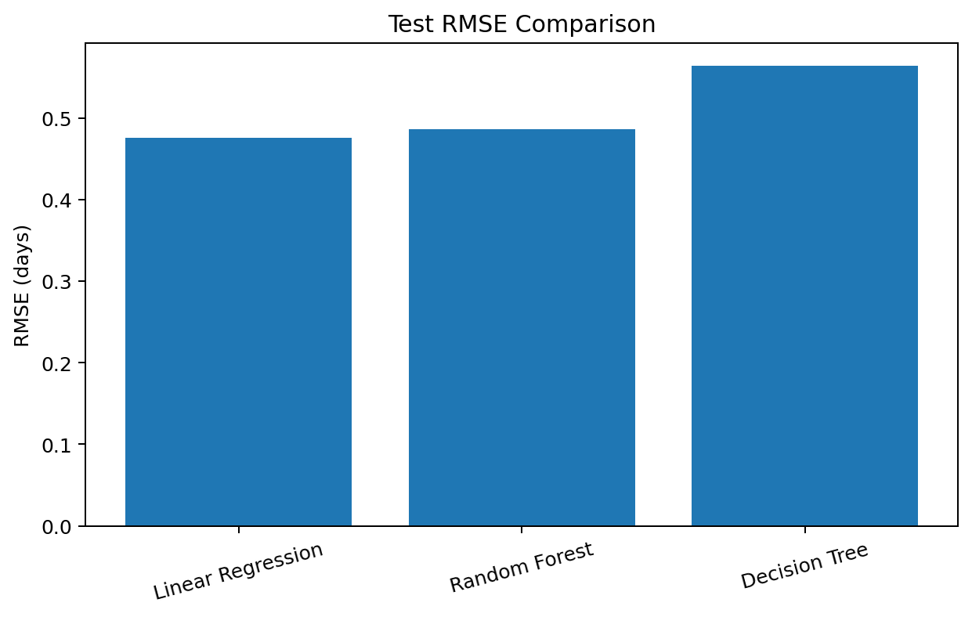
7. Hyperparameter Tuning Results
GridSearchCV selected these Random Forest settings: {'model__max_depth': None, 'model__min_samples_leaf': 4, 'model__n_estimators': 200}. The best cross-validation RMSE was 0.557 days. On the held-out test set, the tuned model achieved MAE = 0.388 days, RMSE = 0.480 days, and R² = 0.851. These are results on a small hypothetical dataset and should be treated as a demonstration rather than proof of real-world forecasting accuracy.
8. Optimization Strategies
Use predicted delivery time as an early-warning signal. Flag shipments whose predicted delivery time exceeds the promised delivery window and review those shipments before dispatch.
Prioritize operational review for long-distance shipments and transport modes/regions with higher observed average delivery times, while checking capacity, service level, and contractual constraints before changing assignments.
Use cost and delivery predictions together when comparing transport options; do not minimize cost alone if doing so increases late deliveries.
Improve data collection by recording actual dispatch time, route, weather/disruption events, vehicle capacity, hub dwell time, and actual arrival time. These features may improve prediction quality.
Monitor MAE and RMSE on new real shipments each week. Retrain only when enough fresh, representative data is available and performance changes are confirmed.
Validate recommendations through a small pilot and compare delivery time, on-time rate, and cost before and after the change.
9. Limitations
The dataset is hypothetical and contains only a limited number of records. The model learns patterns present in the simulated data, which may not reflect actual logistics operations. Important real-world factors such as traffic, weather, route choice, depot delays, vehicle availability, and holiday demand are not included. Therefore, predictions and recommendations must be validated using real operational data before deployment.
10. Conclusion
This project demonstrates a complete predictive workflow for logistics delivery-time forecasting, including preprocessing, comparison of three regression approaches, test evaluation, cross-validation, and Random Forest hyperparameter tuning. The tuned model's test RMSE is 0.480 days and its test MAE is 0.388 days on this dataset. The practical value is in using predictions to identify shipments that may need attention, balancing cost with service level, and improving future data collection. Since the data is hypothetical, real-world deployment requires validation on actual shipment records.
Appendix: Reproducibility
Python packages used: pandas, numpy, matplotlib, scikit-learn, and python-docx for report generation. The notebook uses random_state=42 for the split and models where applicable. Run cells from top to bottom and upload the same CSV file when prompted.

